HUMBER INSTITUTE OF TECHNOLOGY

AND ADVANCED LEARNING

(HUMBER COLLEGE)

**Group Assignment Report**

**Machine Learning 1 - BIA-5302-0GA**

Group - 7

Data Set- **Boston Housing** (The Boston House-price Data, n.d.)

Submitted by:

|  |  |  |
| --- | --- | --- |
| **Last Name** | **First Name** | **Student Number** |
| Das | Subhanjan | N01431473 |
| Patel | Hardi | N01480409 |
| Shah | Divyansh | N01472284 |
| Shand | Yuvraj | N01479401 |
| Tyagi | Abhi | N01474042 |

Submitted to: Professor Salam Ismaeel

Submission Date: 2022-09-19

INDEX

**PART A** **3**

**PART B** **4**

**B.1: Handling missing Data 5**

**B.2: Find possible outliers 6**

**PART C** **7**

**C.1: Omission and imputation on python 7**

**C.2: Substituting the missing Data by NaN 8**

**FINAL RESULT 9**

**REFERENCES** **10**

# **PART A**

*Make a review of such techniques, data, and examples with references.*

Outliers are the values that do not fit the data type or range of the data. Outliers can be of different data types and we can detect and treat outliers using the methods mentioned below. An everyday example of an outlier can be the salary disparity between an employee of an organisation and the CEO of the same organisation.

Outliers (Cause) -

* Data-entry errors - These errors include decimal misplacements, value misplacement, and errors that occur during data entry.
* Measurement errors - These errors occur when there is a discrepancy in the measurement process of the data. These values may not always be wrong but induce errors in models. (Shmueli et al., 2019)
* Missing Values - The errors may occur due to misinterpretation of data by humans, equipment error, losing of samples while recording values, and others.

Outliers (Review) -

* Box Plot - Outliers can easily be visualized with the help of box plots. A box plot divides and maps the data into 4 quartiles (0-25%, 25%-50%, 50%-75% and 75%-100%).
* Sorting Values -It is used to anticipate the locations of unsorted data components within a sorted sequence. We can sort a column in python with the help of the sort_values() function. (Shmueli et al., 2019)
* Statistical Methods - quantile(), z score
* isnull() - We can find null values with the isnull() command
* isnan() - We can find NaN values with the isnan() command
* Manually setting a range - Instead of using statistical methods to find the min-max limits, we can manually

Outliers (Treatment) -

* Outlier trimming: This is not the most effective method for treating outliers since we can lose a lot of data by using this method and can have an impact on the dataset.
* Mean, Median imputation: The process of replacing missing/NaN values.
* Outlier capping: It is used to set a limit above or below a particular value for the field. (Goyal, 2022)

# 

# **PART B**

Here, we will be using the Boston Housing Dataset. (The Boston House-price Data, n.d.)

**Importing excel file to Pandas Data Frame**

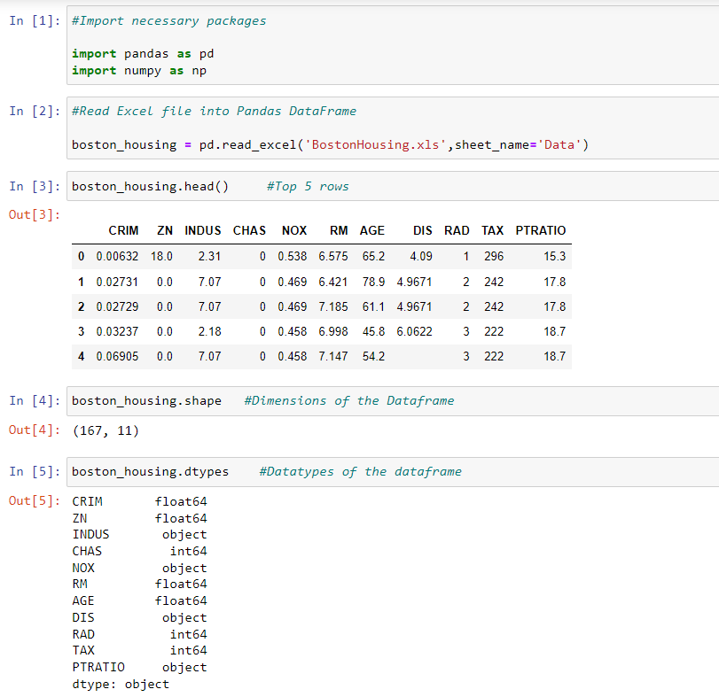

Here we import the necessary packages and read the excel file using Pandas Data Frame.

**B.1: Handling Missing Data**

**Creating Functions to highlight missing and wrong values with a yellow background**

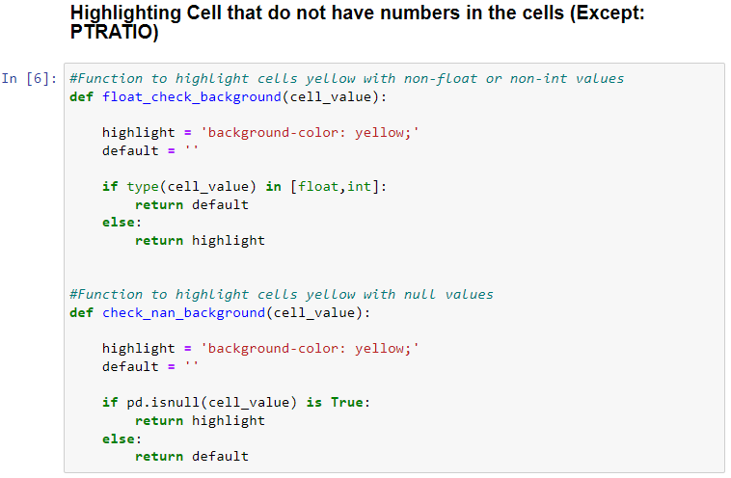

The above function float_check_background returns yellow background to the cells that do not have any number in them along with that check_nan_background returns yellow background to the cells with null or NaN values with the code referenced from (Felipe, 2022):

In the image below we run the above two functions to apply that function to all the columns except ‘PTRATIO’

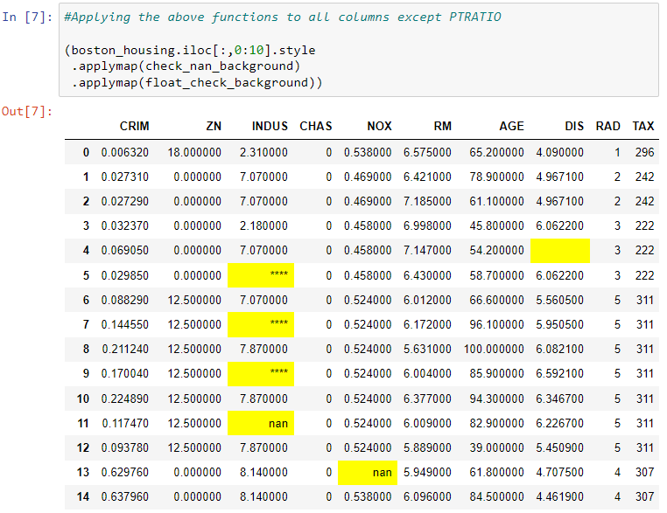

**B.2:** **Find possible outliers**

**Creating a function to highlight outliers with a yellow background in the PTRATIO column**

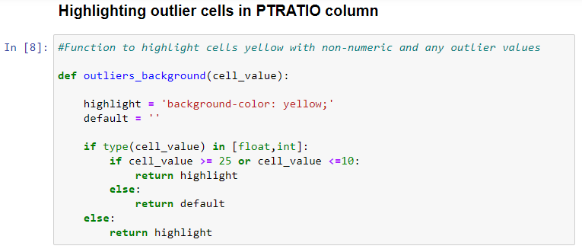

In the above function, we have set the limits for the PTRATIO column, where the values below 10 and above 25 will be highlighted in yellow. (Felipe, 2022)

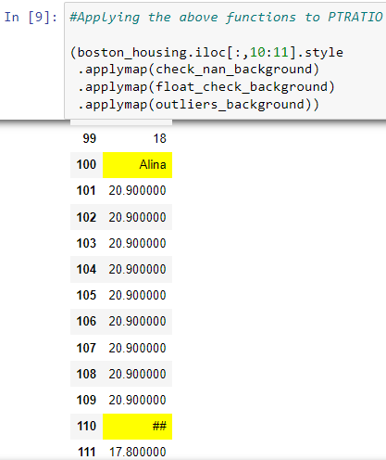

Here we were able to identify different outliers in the PTRATIO column

(a) **Typing non-numeric value:** Identified in index 100, 110, 117

(b) **Shift in decimal place while data entry error:** Identified in index 54

(c) **Genuine case of an outlier:** Identified in index 5, 13, 20, 31, 34, 74, 144, 145

# 

# **PART - C**

**C.1: Omission and imputation on python**

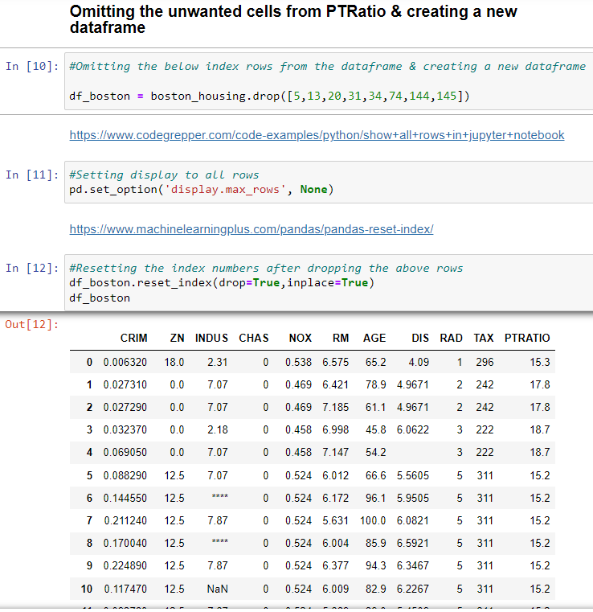

In the above image, we drop the rows that we identified as ‘genuine outliers’ and would not have an impact on the data if removed. To display all the rows we used the pandas function set_index. (Codegrepper, 2020)

Once the rows are removed we lose the index of those columns as well so we reset the index of the whole data frame to make further analysis easier.(MachineLearningPlus, 2022)

In the below image we change the value of the cell we identified as a decimal typing error to 21.1 using iloc from pandas data frame

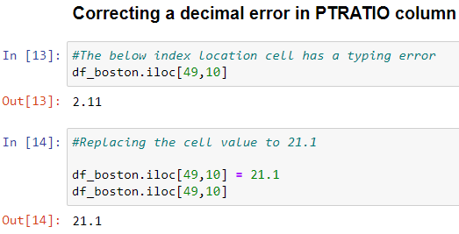

Next, we identified all the other outliers and replaced them with NaN for them to be imputed by the median of the columns.

**C.2: Substituting the missing Data by NaN**

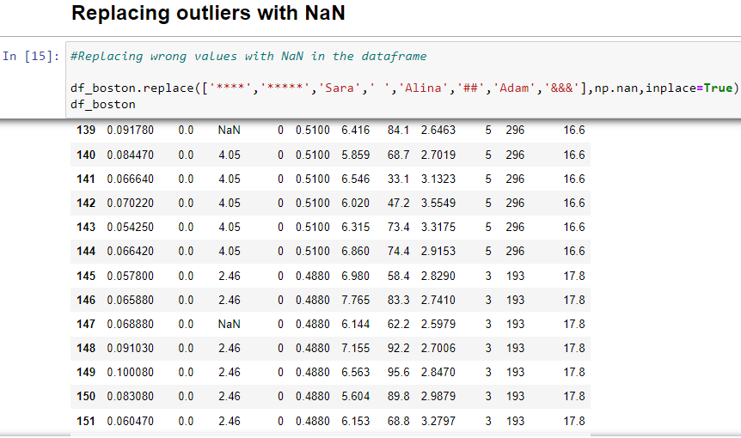

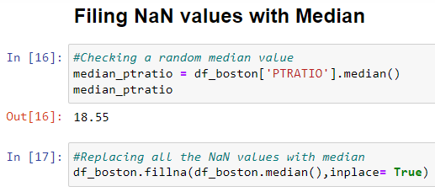

**FINAL RESULT - CLEAN DATASET**

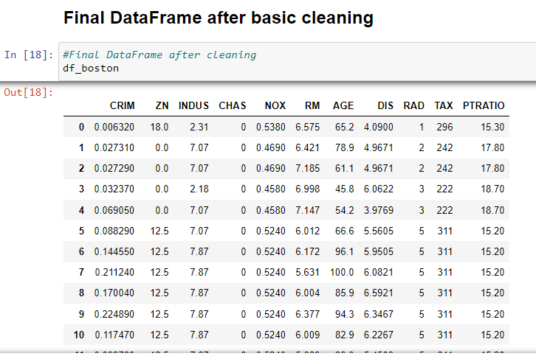

# **REFERENCES**

Felipe. (2022, May 7). *Pandas dataframe examples: Styling cells and conditional formatting*. queirozf.com. Retrieved September 19, 2022, from https://queirozf.com/entries/pandas-dataframe-examples-styling-cells-and-conditional-formatting

Frantic Fowl. (2020, February 25). *Show all rows in Jupyter notebook code example*. Show all rows in jupyter notebook Code Example. Retrieved September 19, 2022, from https://www.codegrepper.com/code-examples/python/show+all+rows+in+jupyter+notebook

Goyal, C. (2022, August 25). *How to detect and remove outliers: Outlier Detection and Removal*. Analytics Vidhya. Retrieved September 19, 2022, from https://www.analyticsvidhya.com/blog/2021/05/feature-engineering-how-to-detect-and-remove-outliers-with-python-code/

MachineLearningPlus. (2022, March 8). *Pandas reset index - how to reset the index and convert the index to a column?* Machine Learning Plus. Retrieved September 19, 2022, from https://www.machinelearningplus.com/pandas/pandas-reset-index/

Shmueli, G., Bruce, P. C., Gedeck, P., & Patel, N. R. (2020). *Data mining for Business Analytics: Concepts, techniques and applications in Python*. John Wiley & Sons, Inc.

*The Boston house-price data*. (n.d.). http://lib.stat.cmu.edu/